Student ID | 201902669 | Name | Kim woo sung
Topic | Binary search tree
Learning Objectives | The students can understand the basic concept of binary tree by implementing binary search tree
Problem 1  [30 points] | Assume that data is inserted as following order.  5 3 7 2 4 6 9 1 8 10  1) Show the shape of binary search tree.(10 points)  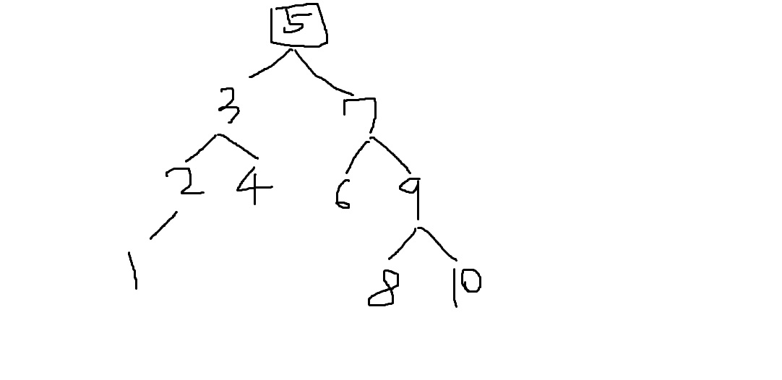  2) Show the contents of array if the data is stored in one dimensional array.(10 points)  3) Show the visited nodes in sequence when the user search the number 8.(10 points)  5 -> 7 -> 9 -> 8
  0 | 1 | 2 | 3 | 4 | 5 | 6 | 7 | 8 | 9 | 10 | 11 | 12 | 13 | 14 | 15
   | 5 | 3 | 7 | 2 | 4 | 6 | 9 | 1 |  |  |  |  |  | 8 | 10
Problem 2  [70] | Develop your program that handles the information of students using binary search tree.  Node in the binary search tree store student name, student ID and department name. The student name and department name are shorter than 10 characters. The Student Id is 9 digits integer. The names are one word and consist of alphabets only.  [Functional requirements]  - A user can select from ‘insert’, ‘search’, ‘delete’ and ‘quit’.  - When the user select ‘insert’, the program requests an input data as following order; student name, student id, department name.  - If name is already stored in the tree, the program show ‘Already inserted’ as an error message.  - The program prints that inserted data is which child and which node’s child. For example, if the inserted data is first node then print ‘The first node’, if ‘Kim’ is inserted after ‘Kang’, then print ‘Kim is inserted as the right child of Kang’  - When the user select ‘search’, the program requests a name as input data from the user and if there is node which has a same name in the BST, then the program prints (student name, student ID, department name).  - When the user select ‘delete’, the program requests a name as input data and delete node which has a same name. If node is deleted, the program prints ‘Successfully deleted’. If there is no matched name in BST, print ‘Not available’ as error message.  1) Define new data structure element that represent node in student list tree based on below definition.(15 points)  typedef struct { char name[10]; } element;  typedef struct node *treePointer;  typedef struct node {  element data; treePointer leftChild; treePointer rightChild;  };  Typedef struct{  Char name[10];  Char department[10];  Int ID;  }element;  Typedef struct node *treePointer;  Typedef struct{  student data;  treePointer leftChild;  treePointer rightChild;  }node;  2) Describe an algorithm that determine the position at which the node has to be inserted in the binary search tree.(15 points)  Input student name, id, department name  If no root, input student is root.  compare the root student and input student  if the root < input, input become the left child  else the root > input, input become the right child  3) Using an algorithm described in 2), develop a function findPosition(treePointer *root, char *k) which return the position at which the node has to be inserted in the binary search tree.(10 points)  Node* findPosition(Node* root, char* value)  {  int count = 0;  if (root==0)  {  root = (Node*)malloc(sizeof(Node));  root->value = value;  return root;  }  else  {  int a = strcmp(root->value, value);  if (a == 1) {  root->leftChild = findPosition(root->leftChild, value);  if (count == 0) {  printf("%s == the left child of %s\n", value, root->value);  }  count++;  }  else  root->rightChild = BST_insert(root->rightChild, value);  if (count == 0) {  printf("%s == the right child of %s\n", value, root->value);  }  count++;  }  return root;  }  4) Describe an algorithm that delete specific data in the binary search tree. If the deleted node has two child, There are two principles which decide the replaced node instead of deleted node; the greatest node in the left sub tree or the smallest node in the right sub tree. Describe the algorithm by selecting one of these two principles (5+5 points)  - when the deleted node has a child  Connecting deleted node of a child and its parent node.  - when the deleted nod has two children,  [reference: refer case of ‘delete Lee’ in the below BST]  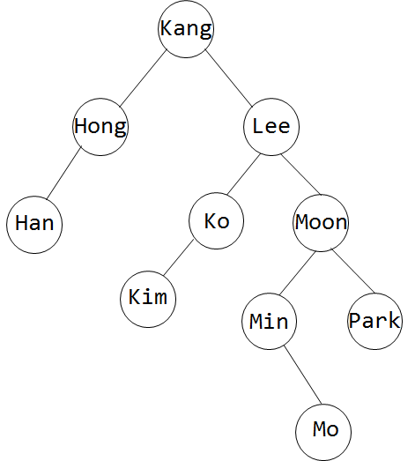  ‘Ko’ is the left child node at ‘LEE’ and ‘MIN’ is the right node at ‘LEE’. For two-child node deletion, we have two option to divide. The first option is that we replace ‘Lee’ to ‘ko’. The second is the method that changes to the smallest of right children. ‘Min’ is replaced by ‘Lee’ and the node is positioned according to the value of ‘Mo’.  5) Using the algorithm described in 4), develop a function deleteNode(treePointer *root, char *k) that deletes the node with the input name from the binary search tree. Utilize the search() function from Problem 2.(10 points)  Node* deleteNode(Node* root, char* value)  {  Node* treeNode;  if (root == NULL)  return 0;  if (root->value > value == 1)  root->leftChild = deleteNode(root->leftChild, value);  else if (root->value < value == -1)  root->rightChild = deleteNode(root->rightChild, value);  else  {  if (root->rightChild != NULL && root->leftChild != NULL)  {  tNode = findMinNode(root->rightChild);  root->value = treeNode->value;  root->rightChild = deleteNode(root->rightChild, treeNode->value);  }  else  {  if (root->leftChild == NULL) {  treeNode =root->rightChild;  }  else {  treeNode = root->leftChild;  }  return treeNode;  }  }  return root;  }  6) Develop a program which handles student information in a binary search tree. Make use of the functions such as search(), findPosition(), and delete(). Check your program when the user input sequence is like the following. (10 points)  “insert” “kang 201420323 software”  “insert” “han 201423045 security”  “insert” “song 201321045 software”  “search” “song”  “insert” “kim 201324956 electronics”  “insert” “yoon 20123045 software”  “search” “kim”  “delete” “han”  “insert” “han 201423055 security”  “search” “han”  #include <stdio.h>  #include <stdlib.h>  #include<string.h>  typedef struct NodeStruct  {  char value[10];  struct NodeStruct* leftChild;  struct NodeStruct* rightChild;  }Node;  Node* root = NULL;  Node* insert(Node* root, char* value)  {  int a;  int b = 0;  if (root == NULL)  {  root = (Node*)malloc(sizeof(Node));  strcpy(root->value, value);  return root;  }  else  {  a = strcmp(root->value, value);  if (a == 1) {  root->leftChild = insert(root->leftChild, value);  if (b == 0) {  printf("%s == the left child of %s\n", value, root->value);  }  b++;  }  else  root->rightChild = insert(root->rightChild, value);  if (b == 0) {  printf("%s == the right child of %s\n", value, root->value);  }  b++;  }  return root;  }  Node* findMinNode(Node* root)  {  Node* tmp = root;  while (tmp->leftChild != NULL)  tmp = tmp->leftChild;  return tmp;  }  Node* Delete(Node* root, char* value)  {  Node* tNode = NULL;  if (root == NULL)  return NULL;  if (root->value > value == 1)  root->leftChild = Delete(root->leftChild, value);  else if (root->value < value == -1)  root->rightChild = Delete(root->rightChild, value);  else  {  if (root->rightChild != NULL && root->leftChild != NULL)  {  tNode = findMinNode(root->rightChild);  strcpy(root->value, tNode->value);  root->rightChild = Delete(root->rightChild, tNode->value);  }  else  {  tNode = (root->leftChild == NULL) ? root->rightChild : root->leftChild;  free(root);  return tNode;  }  }  return root;  }  bool BST_search(Node* root, char* value)  {  if (root == NULL)  return false;  if (strcmp(root->value, value) == 0) {  return true;  }  else if (strcmp(root->value, value) == 1)  return BST_search(root->leftChild, value);  else  return BST_search(root->rightChild, value);  }  void BST_print(Node* root)  {  if (root == NULL)  return;  printf("%s ", root->value);  BST_print(root->leftChild);  BST_print(root->rightChild);  }  int main()  {  char name[10];  int id;  char department[10];  int option;  int b = 0;  int count = 0;  char stu_name[10];  while (1)  {  printf("1 : insert 2 : search 3 : delete 4 : terminate\n");  scanf("%d", &option);  if (option == 1) {  if (b == 0) {  scanf("%s %d %s", name, &id, department);  root = insert(root, name);  b++;  }  else {  scanf("%s %d %s", name, &id, department);  if (BST_search(root, name)) {  printf("Already existed\n");  }  else  root = insert(root, name);  }  }  else if (option == 2) {  count++;  printf("Name : "); scanf("%s", stu_name);  if (BST_search(root, stu_name)) {  }  else {  printf("Cannot search\n");  }  if (count == 1) {  printf("song 201321045 software\n");  }  else if (count == 2) {  printf("kim 201324956 electronics\n");  }  else if (count == 3) {  printf("han 201423055 security\n");  }  }  else if (option == 3) {  printf("Name : ");  scanf("%s", stu_name);  if (BST_search(root, stu_name)) {  Delete(root, stu_name);  }  else {  printf("Not available");  }  }  else if (option == 4) {  break;  }  }  }

